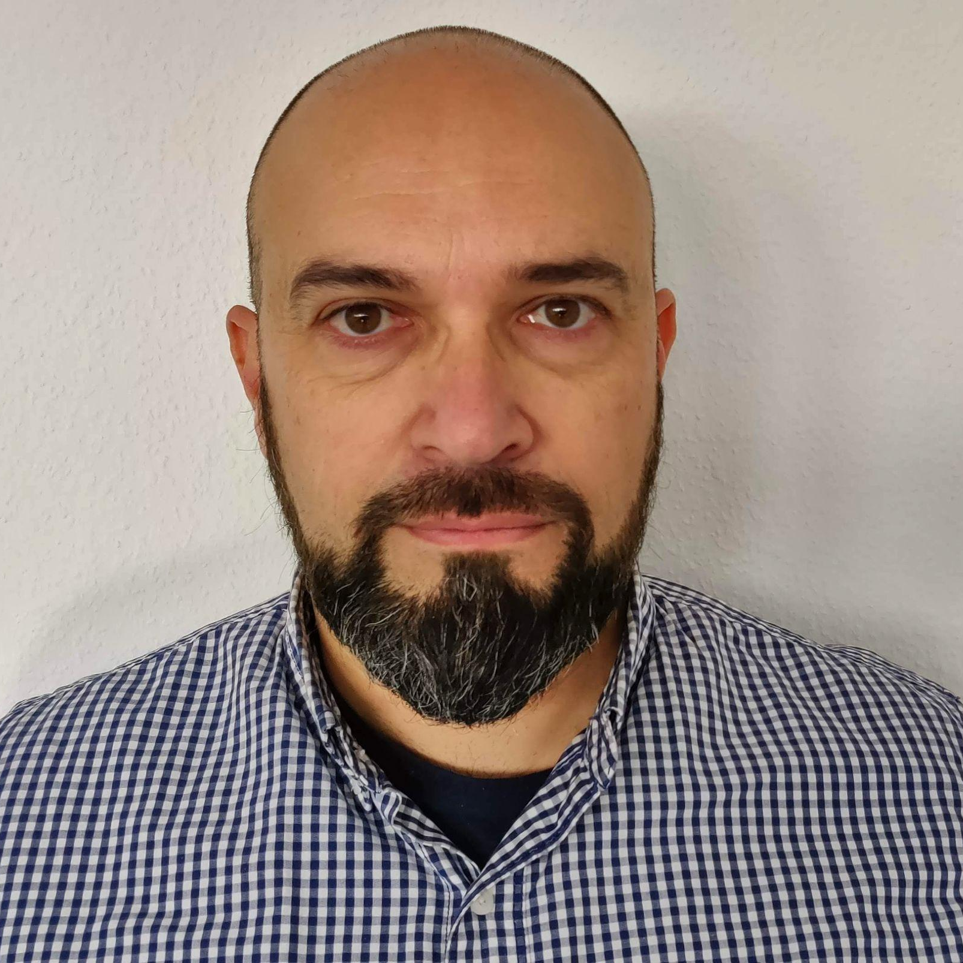 | ROBERTO SCIASCIA rev. August 2021  Phone: +49 1520 441 4241  Email: roberto.sciascia@gmail.com  LinkedIn: https://www.linkedin.com/in/robertosciascia/  Web: http://www.robertosciascia.com

PROFILE  I’ve been a certified Professional Product Owner and Scrum Master for more than 10 years with another decade of software development experience before. I’ve worked in many roles, in many business areas, in different countries, in huge or small companies. I’ve been exposed to the full Software Development Life Cycle and I like to work side-by-side with my teams.  My current position is Product Owner and my job is to collect requirements, prioritize them on the product backlog according to my stakeholders' and business needs and my personal take on the product and its development challenges, keep communication flowing and make my team engaged, productive and aligned to the delivery plan.  SKILLS  Scrum, Kanban ✪ ✪ ✪ ✪ ✪  Agile coaching ✪ ✪ ✪ ✪  Requirement engineering ✪ ✪ ✪ ✪  Team leading ✪ ✪ ✪ ✪  People management ✪ ✪ ✪  Automotive ✪ ✪ ✪ ✪ | WORK EXPERIENCE  Product Owner - BMW, Ulm, Germany (2015.02 > Present)  Delivered Speech support and 3 generations of BMW’s Touch Command within-house and outsourced teams.  Currently working on Projected Modes for the new BMW’s platform debuting in 2023.  Development manager ad interim, Product Owner and Agile Coach - SatProf Engineering, Almere, NL (2014.06 > 2015.01)  Helped with the recruitment and the performance evaluation of a new team in the Netherlands, led the agile transformation and delivered a series of security-related server-side applications and tools for access control in digital television.  Product Owner - eVision Industry Software, Den Haag, NL (2013.05 > 2014.01)  Directed the in-house team to deliver, demo and support several customization of the in-house product targeted at oil & gas customers all around the world.  (Senior) Software engineer, Scrum Master and Product Owner - Irdeto Access, Hoofddorp, NL (2008.09 > 2013.04)  As a developer, delivered several products coded in PHP, C, C++, .Net, Java and Python taking the leadership when required learning the principle of Agile and Scrum on the field, eventually delivering one of the first company’s products with these methodologies.  As a SM and developer, coded and led my team to release other products for digital television’s access control.  As a PO, coached another team and delivered two server-side applications.  EDUCATION  Università degli Studi di Pisa (2004)  Bachelor degree in Computer Engineering (BEng) in 2004.  Scrum Alliance (2011)  Scrum Master (#128662) certification.  Mountain Goat with Mike Cohn for Scrum Alliance (2013)  Product Owner certification.  Scrum Alliance (2016)  Certified Scrum Professional certification.  Hood Group (2016)  IREB® CPRE Certified Professional for Requirement Engineering certification.  University of Cape Town, UCT (2020)  Project Management Foundation short course.  LANGUAGE SKILLS  Italian: Mother tongue (ILR 5)  English: Full professional proficiency (ILR 4)  PERSONAL INFORMATION  Marital status: Married, no children.  Birth: January, 16th 1969 in Orbetello (Italy), Italian nationality.  Driving licenses: A, B European; BMW B0, B1, B2, E1.  Current address: Zeitblomstraße 31, 89073 Ulm, Germany.  Mobile: +49.1520.441.4241  Web: http://www.robertosciascia.com  LinkedIn: https://www.linkedin.com/in/robertosciascia/  Scrum All.: https://www.scrumalliance.org/profiles/rsciascia  Groups: Member of Agile Amsterdam (2013-2015), Agile Munich (2015-today).  Personal interests: Photography, motorbiking, travels, football, tennis, gym.  References: Available on my LinkedIn profile.

